Abstract
Research into the water based scintillation cocktail to be used in the T2K Project’s 280m Near Detector was the main aim of this research. Clear cocktails made with 50%, 60% and 70% water by volume were produced and their photon emittance was tested. Although the 50% water cocktails gave the best photon yield, it was decided that a higher than 50% water concentration is required. Consequently, a 70% water cocktail is currently favoured to appear in the final design.
The possibility of using a gel form of a water based scintillator was explored. Despite expectations, it was discovered that Carbopol gel cocktails do not significantly hinder leaks or significantly retard the degradation of the polystyrene core of wavelength shifting fibers. These findings combined with the inherent difficulty in handling a scintillating gel have pushed the liquid cocktail into favour.
Various materials were tested for their resistance to the scintillor, Quicksafe A, the most important of which were the main structural materials. Polyvinyl chloride (PVC), polycarbonate and polypropylene were eliminated from the possible structural materials, leaving High Density Polyethylene (HDPE), which is yet to be tested.
The attenuation length of the wavelength shifting fibers was tested using a 70vol% water, 27.5vol% Quicksafe A, 5vol% Triton X-100 cocktail. The resulting attenuation length of 1.6m is much shorter than the expected 3m.

- Introduction
Many hurdles in the research on the Near Detector for the T2K project at TRIUMF had already been attained prior to the initiation of the research presented in this document. Among them, the most important was the decision to use Quicksafe A¹ (QSA) as the scintillator in the water/scintillator mixture. A mixture of scintillators and other chemicals is referred to, by the industry, as a “cocktail”. QSA contains the primary scintillator-diisopropylnaphthalene, a surfactant similar to Triton X-100, and some wavelength shifting components. Also chosen to comprise part of the cocktails were the surfactant Triton X-100 (Triton) and in some cases the gelling agent, Carbopol EZ-3 (Carbopol). Together with water, these constituents could be used to produce a clear liquid cocktail or Carbopol gel cocktail containing 72% water, 19% QSA and 9% Triton by volume. These cocktails were clear and produced a decent photon emittance; however, the adequacy of that level of photon production and whether it could be increased came into question. Thus, the primary aim of the research presented here became attempting to increase the photon production while maintaining a high water content in the cocktails.
Also of concern is the resistance of the Near Detector’s materials to the scintillation cocktail. QSA is known to attack various plastics, including the polystyrene core of the wavelength shifting fibers. These issues were explored in the hopes of guaranteeing a ten year lifespan for the Near Detector.
- Background Knowledge
  - The History
In 1930, Wolfgang Pauli first predicted the existence of a vanishingly small particle to help solve the confounding lack of conservation of energy and momentum in beta decay. This particle was dubbed the ‘neutrino’, meaning ‘little neutral one’, by Enrico Fermi and was first detected in 1956 by Frederick Reines and Clyde Cowan. In actual fact, Reines and Cowan successfully detected the first electron neutrino (ν_{e}), which is one of 3 flavours of neutrinos. The second and third neutrino flavours, muon neutrinos (ν_{μ}) and tau neutrinos (ν_{τ}), were first detected in 1962 and 2001 respectively. From the first measurement of solar neutrino flux (the number of neutrinos emitted by the Sun) by Ray Davis in the late 1960’s to 2001, the problem with solar neutrinos was that scientists were not detecting as many neutrinos as they expected to detect. Try as they might, they could only detect about one third of the number of solar neutrinos (ν_{e}) that were predicted to be emitted from the Sun by the standard solar model. Many scientists believed that the solar neutrino deficit was due to uncertainties in the standard theoretical model of the Sun as opposed to an error in the standard model of particle physics. Hence, this deficit became known as the Mystery of the Missing Neutrinos and remained a mystery until June 18, 2001. On that day, a collaboration of Canadian, American and British scientists announced that they had solved the Mystery of the Missing Neutrinos with the aid of the Sudbury Neutrino Observatory (SNO), located in Sudbury, Ontario, Canada. SNO produced two numbers. The first was the total flux of neutrinos being emitted by the sun, which agreed perfectly with the theoretical predictions made by astrophysicists. The second was the number of emitted electron neutrinos, which was only one third of the total number of neutrinos emitted by the sun. These findings proved that electron flavoured neutrinos change flavours as they travel between their point of creation in the Sun and our terrestrial detectors. This change, or mixing, of flavours is a quantum mechanical process known as neutrino oscillations. The existence of neutrino oscillations meant that the standard model of particle physics was not complete. According to the current standard model, neutrinos were massless; however, for neutrino oscillations to occur, the neutrino must have a mass, albeit a small one. Thus, the seal of a new chapter in particle physics had been broken. By studying neutrino oscillations, scientists may be able to pin down the values of neutrino “mixing angles”, which are constants that describe the degree to which one flavour of neutrino can transform into another flavour.
  - The Tokai to Kamioka (T2K) Project
    - Overview
The purpose of the T2K Project is to witness the oscillation of muon neutrinos into electron neutrinos. A new 50GeV synchrotron is being built in Tokai, Japan, called the Japan Proton Accelerator Research Complex (JPARC) to produce a sufficiently intense beam of muon neutrinos. This synchrotron will accelerate protons and direct them into a graphite target, producing a large flux of π mesons. These π mesons travel down a 280m long tunnel, decaying into muons (μ) and ν_{μ} on the way. The resulting neutrino beam travels through an iron beam dump, earth, a Near Detector at about 280m beyond the graphite target and then the 295km to Kamioka, Japan. There, it will strike the Far Detector, Super Kamiokande, which is a 50kTon, cylindrical, water filled cerenkov detector. The detected neutrinos are compared to the expected number of neutrinos and the disappearance of any muon neutrinos is noted. Likewise, the appearance of any extra electron neutrinos beyond the expected amount is noted. In this manner, the T2K project hopes to record 3000 neutrino interactions at Super Kamiokande each year. However, because neutrinos travel at the speed of light, the distance between the Near Detector and the Far Detector is not long enough to expect more than about a dozen or so oscillations in a 5 year time span.
    - Current Near Detector Proposal
The current proposed design of the near detector involves thin 1cm X 1cm X 2.5m rectangular tubes filled with a scintillating cocktail. 250 of these tubes will be stacked side by side, creating a sheet of individual ‘detection cells’. The sheets are then glued together in an alternating pattern of horizontal and vertical orientations, as illustrated in Figure 1. This creates a grid system that will allow researchers to pinpoint the location of the neutrino-induced reactions and the directions of the charged particles produced in those reactions.
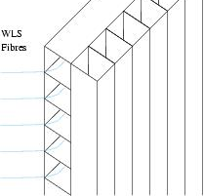
FIGURE 1: Proposed organization of detection cells in the Near Detector. Each sheet of cells will be a single extruded piece of diffusely reflective material that can withstand chemical attack by the scintillation cocktail. The cells are orientated in an alternating horizontal and vertical pattern to provide a 3D readout of the charged particles traveling through the Near Detector. Wavelength shifting fibres will run the length of the cells and transmit events from the cells to photomultiplier tubes.
A wavelength shifting fiber (WSF) will be fed down the length of each cell, terminating at one or both ends with a photomultiplier tube (PMT). The cells themselves are to be made out of a diffusely and highly reflective plastic that can be extruded in large panels. Additionally, the plastic, WSFs and any other materials that are to come into contact with the cocktail must be resistant to the cocktail, otherwise leaks may develop and the detecting efficiency of the detector may become compromised.
The cocktail itself must produce enough light so that events can be identified against a possible expected background noise of 1 to 2 photoelectrons. The scintillator must also have a high enough water concentration and a low enough concentration of other materials that systematic nuclear effects between the Near Detector and the water-filled Far Detector are reduced.

  - The Physics
    - Of Muon Neutrino Creation
In the case of JHF in Tokai, protons are accelerated up to a maximum possible energy of 50GeV and hurtled into a graphite target. The target will release a vast array of particles, including pions (π⁺, π⁰, π⁻), kaons (K⁺, K⁰, K⁰(bar)), protons (p), neutrons (n), electrons (e⁻), and others into focusing magnets that will focus the positive particles (π⁺, K⁺, p) into a decay tunnel. During the trek down the decay tunnel, about 70% of the 2GeV/c π⁺s will decay. 99.9877% of decaying π⁺s will produce a μ⁺ and ν_{μ}.
Likewise, when K⁺s decay, 63.43% will produce μ⁺ and ν_{μ}.
Another 31.71% of the K⁺s will decay into a combination of π⁺, π⁰, π⁻, μ⁺ and/or ν_{μ}. Since the π⁺s decay into a μ⁺ and ν_{μ} most of the time, π⁰s decay into two gamma rays, π⁻s decay into μ⁻ and ν_{μ}(bar) and most of the μ⁺s will not have enough time to decay, the resulting neutrino beam is primarily ν_{μ} with an ν_{e} contamination of ≤ 5%. All non-neutrino particles are stopped at the end of the decay tunnel by an iron beam dump and since neutrinos feel only the weak interaction and gravity to a very small degree, most of them pass through the iron unhindered.
π⁺
μ⁺ + ν_{μ}
K⁺
μ⁺ + ν_{μ}
    - Of Neutrino Detection in Liquid Scintillators
As neutrinos fly through a liquid scintillator, some invariably interact with the neutrons, protons or electrons present in the scintillator. For the T2K Project, two such interactions are important. The first interaction will be utilized in both the Near Detector and the Far Detector.
Here, the ‘x’ can be an e or μ particle. The τ particle is not produced by this reaction because a ν_{τ} does not have enough energy to produce a τ⁻ and a p. The neutron in the reactants is buried in a nucleus (generally a C or O nucleus). Since the e, μ and p all have different masses, the reaction products are ejected in different directions from the interaction point and produce different light intensities depending on the mass and energy of the charged particle. Another characteristic of these particles is their range, which depends on their life span and energy. These characteristics allow the researcher to identify the various particles. Also, the intersection point of the paths of the two reaction products pinpoints where the interaction took place.
The second interaction will also be utilized in both the Near Detector and Far Detector, but the probability of such an interaction is not nearly as high as the first interaction.
The e⁻ is boosted up to a speed near the speed of light (c). A charged particle that is moving through a medium faster than the local speed of light produces a conical pattern of blue and UV photons, much like the electromagnetic equivalent of a sonic boom². By detecting the photons given off by this phenomenon, the direction and type of neutrino can be determined. This reaction also works for muon or tau neutrinos, but the probability of this reaction occurring for a muon or tau neutrino is about 15% of that for an electron neutrino².
X⁻ + p
ν_{x} + n
    - Of Wavelength Shifting Fibers (WSF)
Photons produced in liquid scintillators are detected using photomultiplier tubes (PMTs); however, PMTs have a region of high sensitivity corresponding to a specific range of wavelengths. Consequently, wavelength-shifting molecules are used if the photons produced by the scintillator do not have a wavelength within the range of high sensitivity of the PMT. One such molecule is 2,5-diphenyloxazole (PPO), which will absorb photons and re-emit most of them at a wavelength of 360nm. A secondary wavelength shifting molecule is 1,4-di-2-(5-phenyloxazolile-benzene) (POPOP), which re-emits absorbed photons at a wavelength around 423nm.³ QSA and the WSFs contain some components similar to PPO and POPOP that shift the wavelength into the sensitive range of the PMT. Specifically, the WSFs are composed of a polystyrene core, doped with PPO/POPOP-similar wavelength shifters, and two outer Plexiglas claddings. The innermost cladding is polymethylmethacrylate (PMMA or Plexiglas) while the outermost cladding is fluorinated PMMA. The indices of refraction of the outer cladding, inner cladding and core are 1.42, 1.49 and 1.58 respectively. This allows the fiber to transfer photons down the length of the fiber, via total internal reflection, into the waiting jaws of a PMT. Overall, the fibers have a diameter of 1mm.
ν_{e} + e⁻(moving)

ν_{e} + e⁻(stationary)
- Progress on the Near Detector
  - Liquid Scintillator Development
Ideally, the liquid scintillator will produce more than the required number of photons and will have as high a water concentration as possible. Unfortunately, the acceptable parameters regarding minimum water concentration and minimum photon emission (light yield) have not yet been decided upon by the collaboration. As a result, the minimum useful water concentration was estimated to be 50% by volume and cocktails comprised of 50%, 60% and 70% water were produced. The remaining volume of each sample was comprised of Quicksafe A and the surfactant, Triton X-100 (Triton). For each level of water concentration, varying volumes of QSA and Triton were mixed in order to achieve maximum photoelectron emittance. The volume of Triton used in each sample depended solely on how much volume was required to ‘top up’ the sample to a total volume of 20mL. Triton was chosen to be included in the cocktails because it is a surfactant. As such, Triton and the surfactant already present in QSA aid diisopropylnaphthalene’s miscibility with water.
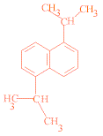
FIGURE 2: Diisopropylnaphthalene is the primary scintillator in Quicksafe A.
The cocktails with a high water and QSA concentration were uniform, clear liquids. The cocktail with no Triton was slightly cloudy or became clouded when warmed. Of the total volume, only about 2.5% - 5.0% Triton is needed to remedy this malady. If the QSA concentration is reduced, and the Triton concentration is increased, the cocktail turns into a natural gel; ‘natural’ meaning that no separate gelling agent, like Carbopol EZ-3, was added to cause the gelling. In fact, a natural gel is simply a very viscous solution. These natural gels are clear, but contain many small bubbles. Fortunately, melting and stirring the natural gel or simply leaving it for 2 weeks can eliminate the bubbles. However, some of the natural gels appear hazy, cloudy or rippled, which cannot be eliminated simply by heating and stirring the cocktail. The phase (liquid or gel) of any particular cocktail depends on the temperature and is summarized in Table 1 for a temperature of 25ºC.
TABLE 1: The phases of various 20mL cocktails at 25ºC. The presented ranges represent the vol% of QSA present in the cocktails made with the listed vol% of water. Triton comprises the rest of the vol% in all cases.
 | 50% Water Cocktails  (% Quicksafe A by Volume) | 60% Water Cocktails  (% Quicksafe A by Volume) | 70% Water Cocktails  (% Quicksafe A by Volume) | General Appearance
Liquid: | 50 – 40 | 40 – 10 | 30 – 0 | Clear fluid
Natural Gel: | 40 - 0 | N/A | N/A | Somewhat clear

Another attempted approach was fixing the concentration of QSA and varying the Triton and water concentrations until a clear cocktail was achieved. This was done for fixed values of 37% and 55% QSA, nearly all cocktails of which were natural gels. Table 2 outlines all of the clear cocktails that were produced.
TABLE 2: Clear, 20mL cocktails at 23ºC.
% Water by Volume | % QSA by Volume | Phase | % Water by Volume | % QSA by Volume | Phase
22 – 24 | 55 | Natural Gel | 50 | 50 – 40 | Liquid
30 – 33 | 37 | Natural Gel | 60 | 40 – 0 | Liquid
50 | 22.5 – 25 | Natural Gel | 70 | 30 – 0 | Liquid
At higher temperatures the cocktails will turn opaquely white; the temperature at which this occurs is referred to as the ‘cloud point’. Table 3 shows the cloud points of various cocktails. This data was acquired by placing the vials containing the cocktails into a water bath. The water bath was heated on a stirring hot plate, agitated, and monitored with a thermometer.
TABLE 3: Cloud point of various cocktails.
50% Water Cocktails |  |  | 70% Water Cocktails
% QSA  (by volume) | % Triton (by volume) | Cloud Point (±1ºC) | % QSA  (by volume) | % Triton (by volume) | Cloud Point (±1ºC)
50 | 0 | 22 | 27.5 | 2.5 | 32
47.5 | 2.5 | 25 | 25 | 5 | 33
45 | 5 | 28 | 22.5 | 7.5 | 36
42.5 | 7.5 | 29 | 20 | 10 | 37
40 | 10 | 29 | 15 | 15 | 41
 |  |  | 10 | 20 | 45
 |  |  | 5 | 25 | >54

  - Gel Scintillator Development
Instead of a liquid, a scintillator in the form of a gel may be desirable in the final detector due to its high viscosity. The two prominent reasons for using a gel are the retardation of material degradation and the prevention of detection cell leaks, which will be further discussed in the Material Resistance Tests section and the Prototype Tests section, respectively. Essentially, a Carbopol gel is produced by incorporating a gelling agent, called Carbopol EZ-3 (Carbopol), into the recipe for a clear liquid cocktail. Carbopol EZ-3 thickens as the pH rises, and reaches a maximum thickness at pH’s between 4.5 and 9.5. Trouble arises from the fact that adding Carbopol and NaOH to a clear cocktail causes the cocktail to cloud over unless the right amounts of Carbopol and NaOH are used. In fact, the clarity of the Carbopol gel is sensitive to the addition of about 1μmol NaOH. This is of utmost importance because the clarity of the cocktail has a profound effect on the light yield. As such, efforts were focused on cocktails that had the highest possible QSA content for its fixed water concentration. The clear Carbopol gels are tabulated in Table 4.
TABLE 4: Clear, 20mL Carbopol Gels at 25°C.
% Water by Volume | % QSA by Volume | Carbopol EZ-3 (g) | 0.5M NaOH (mL)
72 | 19 | 0.12 | 0.125
70 | 25 | 0.1 | 0.122
50 | 45 | 0.15 | 0.04
It should be mentioned that natural gels appear to stiffen as the temperature drops. Thus, natural gels can be returned to a liquid state through heating, whereas Carbopol gels do not revert to a liquid when heated; instead, Carbopol gels become cloudy to the point of opacity.
  - Material Resistance Tests
    - Fiber Degradation
Unfortunately, the scintillator QSA actively decomposes most plastics. This becomes exceedingly important when choosing the WSFs and the material to use for the detection cells in the near detector. It was discovered early on that QSA dissolves the core of the WSFs currently favoured for use in the near detector. Thankfully, QSA does not dissolve the outer cladding of the fibers, which means that the fibers are safe from damage as long as there are no holes in the outer cladding. The first reason to use a gel in the detector, as opposed to a liquid, is the possibility that a gel would slow down the degradation of the fibers if a hole in the cladding were present. To test this, several WSFs were placed into cocktails of varying content and phase. The ends of the fibers (and thus the cores) were left exposed to the cocktail and a notch was cut in each fiber about halfway along its length to simulate a hole in the cladding. These cocktails were then incubated at around 50°C for up to 3 months. All references to incubation in the remainder of this paper refer to a temperature of about 50°C. Figure 3 shows a notch in a fiber and a fiber end. The hollowed out cladding is evident in both pictures.
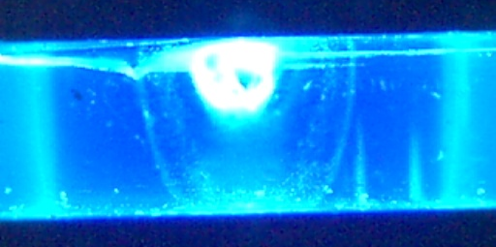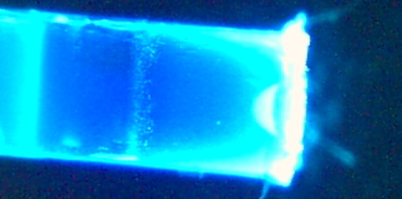
FIGURE 3: Wavelength shifting fibers with sections of core dissolved. The bright material in the fiber is the intact polystyrene core. The left photo is a notch, while the right photo is a fiber end.
During that time, the fibers were periodically removed from the cocktails and the distance of hollowed-out cladding surrounding the notch, and the distance of hollowed out cladding extending from the exposed end of the fiber were measured. The results from three such vials are presented in Figures 4 and 5. The composition of each cocktail is represented by 3 numbers separated by slashes that represent the vol% of water, QSA and Triton respectively. The three incubated cocktails were a liquid 45/55/0, a liquid 21/55/24 and a Carbopol gel 21/55/24. Unfortunately, the three incubated cocktails presented in Figure 4 and 5 each separated into multiple layers. As a result, the concentration of the chemicals in contact with either the notch or the fiber end could not be determined.
FIGURE 4: Deterioration of the wavelength shifting fiber’s polystyrene core, in various 55% Quicksafe A cocktails. These cocktails were incubated at 50ºC and separated over time. “21/55/24” refers to a cocktail made of 21% water, 55% QSA and 24% Triton. The distances refer to the length of hollowed out cladding surrounding the notch.
FIGURE 5: Deterioration of the wavelength shifting fiber’s polystyrene core in various 55% Quicksafe A cocktails. These cocktails were incubated at 50ºC and separated over time. “21/55/24” refers to a cocktail made of 21% water, 55% QSA and 24% Triton. The distances refer to the length of hollowed out cladding measured from the fiber end.

Two other cocktails that were incubated with notched fibers showed some interesting results; both were 72/19/9. One cocktail was a liquid while the other contained Carbopol and formed a stiff gel. Figure 6 shows the degradation rates for both the liquid and the Carbopol gel. The more dilute concentration of QSA meant that the fibers did not show appreciable signs of degradation for about a month; but the limited results are meaningful none-the-less. It appears that the Carbopol gel degrades the fiber faster, contrary to expectations. Similarly, to the previous incubated cocktails, the liquid cocktail separated after 3 months of incubation, suggesting that the concentration of QSA surrounding either the end of the fiber or the notch became unpredictable near the end of the incubation period; however, the Carbopol gel managed to stay uniform.
FIGURE 6: Fibre degradation in a liquid cocktail and a Carbopol gel cocktail. Both cocktails are 72/19/9 and have 3 WSFs. The ‘Distance’ is the length of core that the cocktail has dissolved, extending from the exposed end of the fibre. The error is ±0.2mm.

    - Plastic Survival Challenge
Each and every material that would come into contact with the cocktail in the finished Near Detector was submerged in QSA and incubated to ascertain whether or not that material could be used. Table 5 lists the materials that were tested and whether or not they survived. The incubation periods listed in Table 5 are the time intervals from the materials’ initial incubation to December 8, 2004; at which time, the final status of each material was recorded.
TABLE 5: Quicksafe A resistance of various materials. These observations were made on December 8, 2004.
Material | Observations | Incubation Period (days) | Material | Observations | Incubation Period (days)
QSA | Nothing | 60 | Soft PVC | Turns QSA maroon | 69
Shower Bar Cover | Nothing | 14 | 7181 PVC | Turns QSA mild yellow | 69
Polystyrene Fiber Core | Dissolves | 7 | 3101 PVC | Turns QSA mild yellow | 69
Tyvek | Nothing | 33 | Polycarbonate | Pitted surface | 69
Mylar | Nothing | 33 | Epoxy | Nothing | 63
Yellow Coroplast | Turns QSA mild yellow | 28 | Titanium Silicone II | Nothing | 63
White Coroplast | Turns QSA mild yellow | 22 | Geocel ProFlex Caulking | Dissolves | 14
Black Plexiglas | Turns QSA black | 132 | Lexel | Dissolves | 14
EJ-510 Paint | Detaches from surface | 16 | Buna-N O-ring | Turns the QSA black | 138
EJ-520 Paint | Warps surface | 16 | Viton O-ring | Turns the QSA beige | 114
PVC | Turns QSA mild yellow | 142 | Lexan | Pitted Surface | 78
With the exception of Geocel ProFlex Caulking, Lexel and the EJ-510 Paint, all materials that were not QSA resistant leaked one kind of chemical or another. Consequently, the QSA in which the material was immersed changed colour. The material itself sometimes showed signs of physical deterioration like discolouration and pitted surfaces. The Geocel ProFlex Caulking and Lexel completely dissolved. Also, the EJ-510 Paint, intended for plastic scintillators, cracked and detached from the polypropylene surface it was painted on to.
  - Biological Inhibitor Issues
Sometime during the summer, mould was discovered growing in some of the cocktails. In the interests of eliminating the possibility of mould growth in the finished Near Detector, several biological inhibiters were purchased and incorporated into both Carbopol gels and liquids. The biological inhibiter candidates included Germaben II, Germaben II E, Liquipar Optima, Phenonip and Germall Plus. Of these candidates, Liquipar Optima maintained the best light yield when incorporated into a Carbopol gel; where as all of the candidates faired equally well when incorporated into liquid cocktails. A volume of about 1vol% (0.2mL) of Germaben II, Germaben II E, Liquipar Optima and Phenonip were added to their respective cocktails, while Germall Plus was added in the amount of about 0.5vol% (0.1mL).
Furthermore, each biological inhibiter was incorporated into 3 cocktails: a Carbopol gel, a liquid, and an incubated liquid. Additionally, a control of each type was made that did not contain any biological inhibiter. The two liquid types contained 72% water, 19% QSA and 9% Triton, while the Carbopol gel contained an additional 0.12g Carbopol and 0.125mL 2wt% NaOH. These cocktails were monitored for about 2 months. After this period of time, no sign of growth in the inhibited cocktails or their controls was witnessed. Unfortunately, successfully infecting the cocktails with mould was difficult because it is not known what causes the mould to develop in some cocktails but not in others. In an attempt to confidently infect these cocktails, the clouds of mould in the already infected cocktails were extracted and placed in a vial. 8mL of water was then added to the mould and the mixture was stirred using a model boat propeller. Once the mould was broken up and spread throughout the mixture, 0.5mL aliquots were extracted from the mixture and injected into each of the biologically inhibited cocktails, including the controls. After 2 months, no growth is evident in any of the inhibited cocktails or their controls.
  - Beam Tests
    - Liquid Cocktails
Cocktails of 70% or 50% water were tested in the beam to tabulate their light yield. Each cocktail was mounted in a light sealed container in the comfort of its own vial. The ceiling of this close fitting container was a UV transparent, Plexiglas disk that butted up directly against the photocathode of the PMT. Three holes of diameter 1.2mm were drilled into the top of the vial’s cap, using a #59 drill bit, and three 5.7mm lengths of WSF were inserted through those holes into the vial’s contents. The tops of the WSFs were cut with electrical pliers, sanded with ‘600’ sandpaper and polished with an aluminum oxide buffing compound until they were flush with the cap’s surface, while the bottoms of the WSFs were left exposed to the cocktail. In this manner, only photons passing through the WSFs could enter the PMT. Finally, a strip of aluminized mylar was wrapped around the vial and an aluminized mylar disk was placed beneath the vial with the intension of reflecting any photons that may miss the WSFs while following their erratic path in the vial. Figure 7 shows a picture of the apparatus.
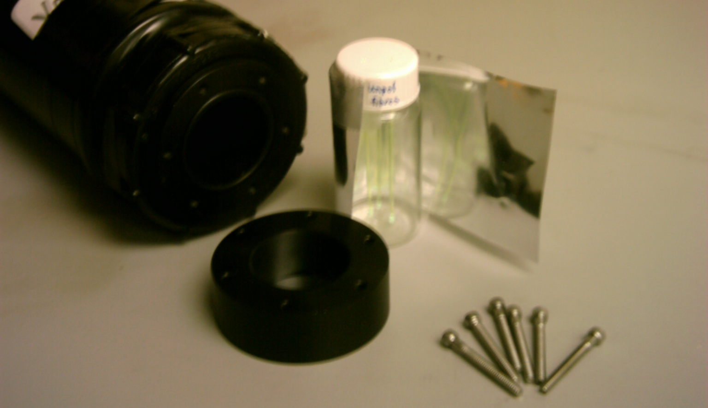
FIGURE 7: Vial testing apparatus. The PMT is in the top left corner.

A plastic scintillator, of dimensions 1.5cm X 1.5cm X 0.3cm, was placed immediately at the end of the beam tube with another plastic scintillator, of dimensions 7.6cm X 7.6cm X 1.3cm, placed 4.4m downstream of the first plastic scintillator. An event occurring simultaneously in these two scintillators opens an electronic window. When that window is open, signals (charges) from the PMT connected to the vial and sample cocktail are integrated, digitized and recorded. The apparatus in Figure 7 was placed in between the two plastic scintillators in such a way that the beam axis would pass directly through the center of the vial. The beam itself is tuned to contain anti-muons (μ⁺), positive pions (π⁺) and positrons (e⁺) with a momentum of 120MeV/c. By measuring the time of flight between the two scintillators, the μ⁺s could be identified. All results in this paper refer to the response of the scintillating cocktail to 120MeV/c μ⁺s.
Figure 8 depicts the light yields of the 70% and 50% water cocktails with a linear fit. The voltage applied to the PMT for these tests was –2000V, the PMT “Jenna” was used, and the attenuator was set to 0.5 for the 50% water cocktails and 0.8 for the 70% water cocktails. The uncertainty in the number of emitted photoelectrons is about ±3. Unfortunately, the two slopes do not carry a great enough uncertainty to be considered equal within experimental error; however, they are similar enough when considering which cocktails will give a higher light yield within the small range of water concentrations being considered.
FIGURE 8: Number of photoelectrons emitted by cocktails with various concentrations of Quicksafe A. The error is ±3 photoelectrons.

On June 8th, an unexplained drop in the light yield of a 72% water, 19% QSA, 9% Triton (72/19/9) cocktail was noted. The issue was re-examined near the end of October and it was found that, surprisingly, the cause of the drastic drop was the cleanliness of the aluminized mylar reflector. A 70/27.5/2.5 cocktail emitted 20.9 photoelectrons using an old aluminized mylar reflector and emitted 62.7 photoelectrons using a new aluminized mylar reflector. Apparently, hand oils, and other grease, smudges the mylar enough that its reflectance is seriously effected. Crinkling the mylar too much will also reduce its reflectance. At this time it was discovered that sanding and polishing the WSFs increased the light yield by about 7%. This was a practice that had not been common beforehand. The data in Figure 8, above, was acquired using the crinkled and unclean aluminized mylar, which means that the data should only be used as a comparison between magnitudes of emittance of the various cocktails.
    - PPO/POPOP
In the past, it was speculated that the inclusion of PPO/POPOP powder in the cocktails would increase their light yield. The PPO/POPOP mixture is a powder with a ratio of 460g PPO : 13.6g POPOP⁴. Two sets of 3 vials containing 70/20/10, 70/10/20 and 70/5/25 cocktails were produced to examine the hypothesis. The first set contained 1g PPO/POPOP per 50mL of Triton. The second set contained 2g PPO/POPOP per 50mL Triton. The amount of triton in the sample was not altered. These cocktails were tested in the beam and their light yields are compared with that of their controls in Figure 9.
FIGURE 9: Light output of scintillator cocktails made with Triton X-100/PPO/POPOP. The concentration of PPO/POPOP is 0g, 1g and 2g per 50mL of Triton X-100.

The light yield of the 70/5/25 cocktail is most affected by the addition of PPO, supposedly because that cocktail contains the largest amount of Triton and PPO, and the least amount of QSA. However, the cocktails produced with 2g PPO/POPOP per 50mL of Triton have a lower light output than cocktails produced with 1g PPO/POPOP per 50mL Triton. Additionally, it appears that the effect of PPO/POPOP diminishes and disappears when there is less than 0.2g PPO/POPOP in the cocktail or when the level of QSA in the cocktail reaches 20%.
  - Prototype Tests
    - Prototype 1
Since the 70/27.5/2.5 cocktail could produce such a high number of photoelectrons (62.7) and was also an easily handled liquid, the first prototype detection cell was filled with this cocktail. This first prototype (Pro 1) would hopefully provide the data required to determine the attenuation length of the WSFs. Pro 1 was constructed with a 188cm long Lucite tube with an inner diameter of 2.2cm, a white, plastic (thought to be PVC) shower bar cover as the reflector (placed inside the Lucite tube), three 2m long WSFs and two custom tube heads which act to seal the tube and hold the fibers tightly in place. After assembly, the entire tube was wrapped in Aluminum foil and the gaps in the foil were sealed with black electrical tape to prevent any entry of light from external sources. Figure 10 shows a picture of Pro 1.
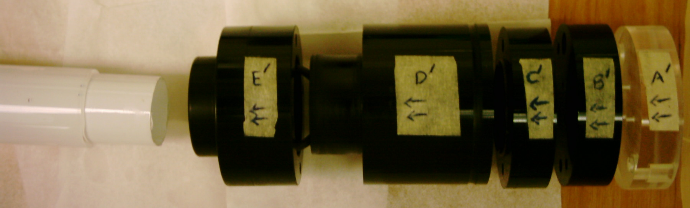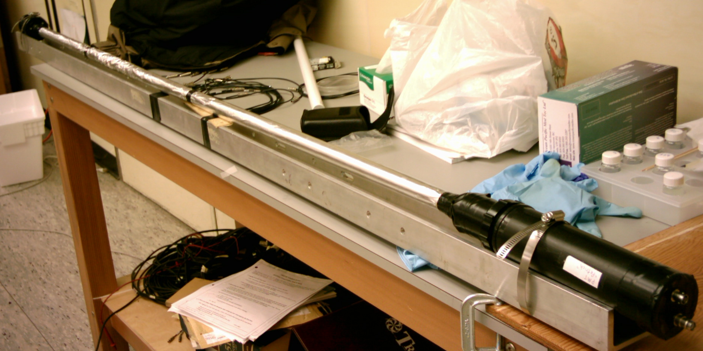
FIGURE 10: Prototype 1 after assembly and an un-assembled custom tube head. The custom tube head threads on to a PMT once assembled.

Pro 1 was mounted on a U-shaped aluminum channel, which was in turn mounted on a movable cart at the end of the beam line. It was mounted vertically, with the PMT at the bottom for measurements lower than or equal to about 90cm from the snout of the PMT, and at the top for measurements greater than 90cm from the snout of the PMT. All measurements were made with the PMT “Patrick”, a PMT voltage of –2150V and the attenuator set to 1.0. The recorded distance from the PMT is actually the distance from the snout of the PMT. In reality, there is 10cm of fiber extending beyond the snout and terminating at the PMT’s photocathode.
Over the first few runs with Pro 1, the light yield was noticeably higher than in the final slew of runs. A measurement taken at a specific position before the seventh run yielded higher numbers of photoelectrons than a measurement at that same position after and including the seventh run. Upon dismantling Pro 1, it was noted that the liquid level had dropped by 1.5cm, the fibers were all intact and the reflector was not noticeably discoloured. As such, this drop in light yield is currently unexplained. Nevertheless, if the data acquired after the 6th run is considered independent of the data acquired from the first 6 runs, the data could be fit to an exponential. Figure 11 depicts the results of the final 17 runs only. The attenuation length is the length at which the light yield has dropped by a factor of e. In this case, that distance, x, is the inverse of the exponent on the base e in the exponential fit. This data suggests an attenuation length of about 1.6m when the fiber is submerged in cocktail.
FIGURE 11: Light yield collected by 3 Wavelength Shifting fibers, immersed in a 70/27.5/2.5 cocktail, as the distance from the snout of the PMT to the beam's path is increased.

    - Carbopol EZ-3 Gels and Leaks
One of the main concerns with the Near Detector is the containment of the cocktail. This provides the second reason to use a gel as the medium for the cocktail. Conceptually, small holes could develop in the Near Detector. The worst position for one of these holes would be at the bottom of a vertical detection cell where the pressure is about 1/3atm (5psi) above atmospheric pressure. To test whether a Carbopol gel would actually prevent a leak altogether, or simply slow it down, a 70/25/5 Carbopol gel with 0.123mL 0.5M NaOH and 0.1g Carbopol was produced in a 20mL disposable syringe with a plugged nozzle. The Carbopol gel was left to set overnight. A hole was drilled in the syringe’s plunger with a #75 drill bit (0.48mm diameter). The plunger was then replaced into the syringe and compressed until a small amount of Carbopol gel welled up through the drilled hole. The syringe’s nozzle was then unplugged and hooked to a tank of pressurized Argon gas. The pressure was increased from 1.5psi until Carbopol gel began to flow freely out of the hole in the plunger, which occurred at around 3.4psi. Very slow seepage of the Carbopol gel was noted as beginning at 2.2psi.
    - Coroplast
Surprisingly, a common material that is used for billboard signs called Coroplast was discovered. This material can be purchased off the shelf, is made of white polypropylene and is nearly the exact dimensions of the proposed sheets of detection cells. The inner dimensions of the rectangular tubes are 8.5mm × 8.5mm × 2455mm, the interior walls are 0.5mm thick and the outer walls are 0.7mm thick. Figure 12 shows a short piece of Coroplast.
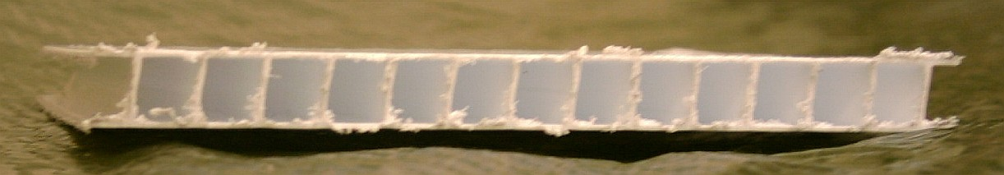
FIGURE 12: End view of a piece of trimmed Coroplast. The walls between cells are 0.5mm thick, the exterior walls are 0.7mm thick and each cell’s dimensions are 8.5mm × 8.5mm.

In addition to the actual production of prototypes from Coroplast, some relatively simple design tests were performed using the Coroplast. The issue of how to effectively seal the ends of the Coroplast cells was of particular interest. Two ideas were attempted; the first involved stuffing the end of the cell with Silicone Rubber. A small length of WSF was held in the opening of the cell end while Titanium Silicone II was squeezed in around the fiber and about 1cm down the cell. Four cells were sealed in this manner and left to cure for a day. After the curing was complete, the cells that were sealed at one end were filled with water, but 3 out of the 4 cells leaked profusely. The single non-leaking cell was left over a few days with some parafilm over the exposed end of the cell. The water level in the cell dropped about 1cm in 3 days. To better simulate the conditions of the finished detector, 8 more cells were plugged with RTV Sealant (another Silicone Rubber). Four of the plugged cells were side by side, one was alone with the adjacent cells unplugged, and the final three were side by side. A strip of black electrical tape and two layers of aluminum foil, attached with double sided tape, further sealed the exterior walls of the set of four adjacent cells from the possibility of evaporation through the polypropylene. This is shown in Figure 13.
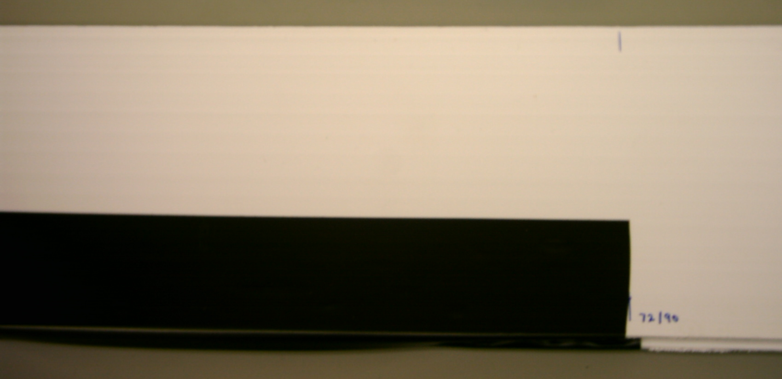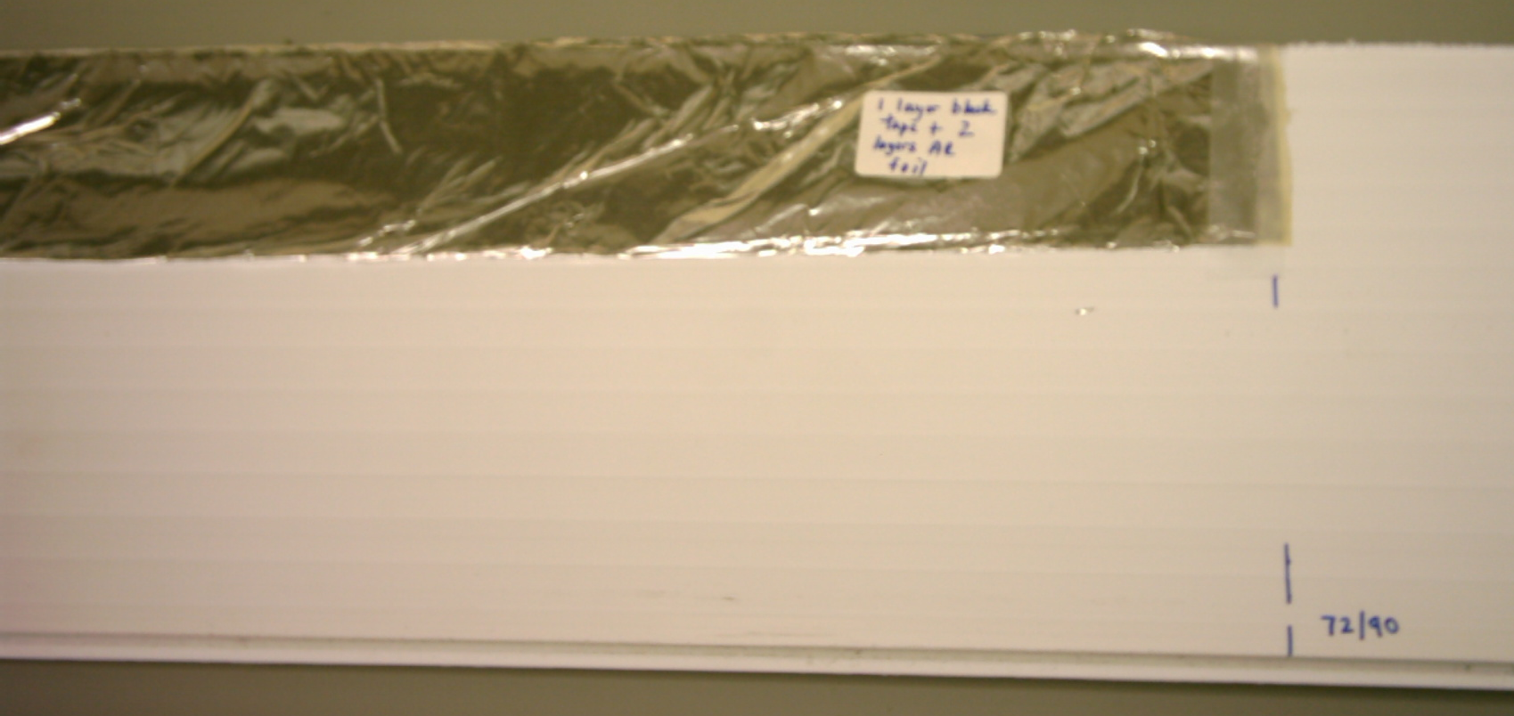
FIGURE 13: These two photos show how the set of 4 detection cells were insulated first with black electrical tape and then with aluminum foil to prevent evaporation.
These eight cells were filled with clear water to test for leaks at the bottom seal. None leaked. Next, blue food colouring was used to dye water to the point where the level of water in any given cell could be observed by shining a flashlight through the coroplast. The eight cells were filled with blue water, sealed at the top with RTV Sealant and the initial level of liquid in each cell was recorded. Table 6 shows the initial results.
TABLE 6: Declining water level in Coroplast detection cells sealed with RTV Sealant.
 | Side by side, and insulated with black electrical tape, two layers of aluminum foil and a strip of double sided tape. |  |  |  | Alone | Side by side
Cell #: | 1 | 2 | 3 | 4 | 5 | 6 | 7 | 8
Day | Distance the water level has dropped from its initial height (mm)
5 | 1.5 | 2.1 | 2.5 | 1.2 | 1.8 | 2.1 | 6.5 | 2.5
18 | 5.3 | 5.8 | 6.2 | 4.9 | 6.1 | 6.9 | 10 | 7
 | Difference between days 5 and 18 (mm)
 | 3.8 | 3.7 | 3.7 | 3.7 | 4.3 | 4.8 | 3.5 | 4.5
All eight water levels sunk very little in the first week, with the largest mover being the center cell of the group of three. It dropped 6.5mm in 5 days, where as the rest only dropped by 1.2mm to 2.5mm in that time. More RTV was added to the top seal on the center cell of the set of 3 on the 5th day (after the large drop was witnessed). The measurements have an uncertainty of ±0.2mm. The drop in water levels between day 5 and 18 seems to suggest that the insulation does indeed help decrease the rate of descent of the water, but more measurements are needed to confirm this.
    - Prototypes 2 and 3
The second prototype, Pro 2, was made from a Coroplast sheet. A single cell, 50cm long, was cut from the sheet and rinsed out with water and isopropyl alcohol. A black, Plexiglas plug, specifically made for this cell, was inserted in one end of the cell and sealed tight with RTV Sealant (Silicone Rubber). A WSF was also inserted through the cell and plug. Then, a vial cap, with a single 1.2mm diameter hole drilled in it, was sealed to the end of the plug, with RTV, such that the WSF stuck out through the hole. Another black, Plexiglas plug was threaded onto the opposite end of the WSF but was not sealed in place. The WSF’s ends were cut, sanded and polished, and a small piece of aluminized mylar was optically cemented to the end of the WSF opposite the vial cap. After waiting for the various adhesives to cure, the cell was filled with a 50/47.5/2.5 cocktail and the second plug was inserted in the upper end of the cell. This second plug remained unsealed to the cell itself throughout the test runs; allowing the prototype to be refilled with a different cocktail at a later date. The entire cell was mounted in a section of Lucite tube just long enough to accommodate it, and the Lucite tube was light-proofed with Aluminum foil and electrical tape as before. Then, the Lucite tube was placed in the upper part of the custom vial holding apparatus described in the Beam Tests section, which effectively placed the polished end of the WSF up against the UV transparent Plexiglas disk. Figure 14 shows both ends of Pro 2.
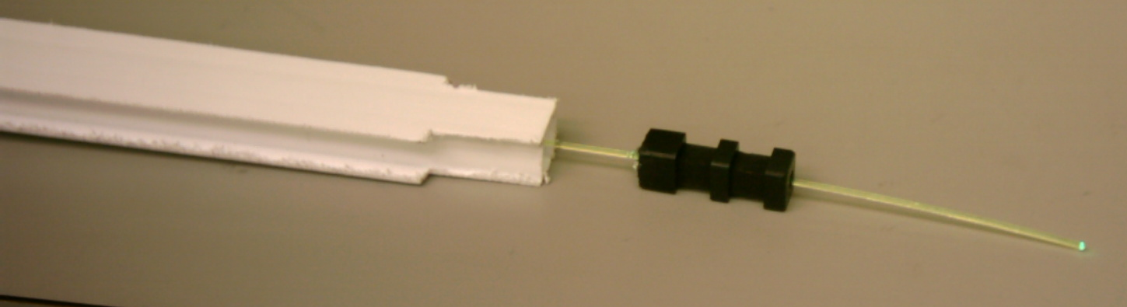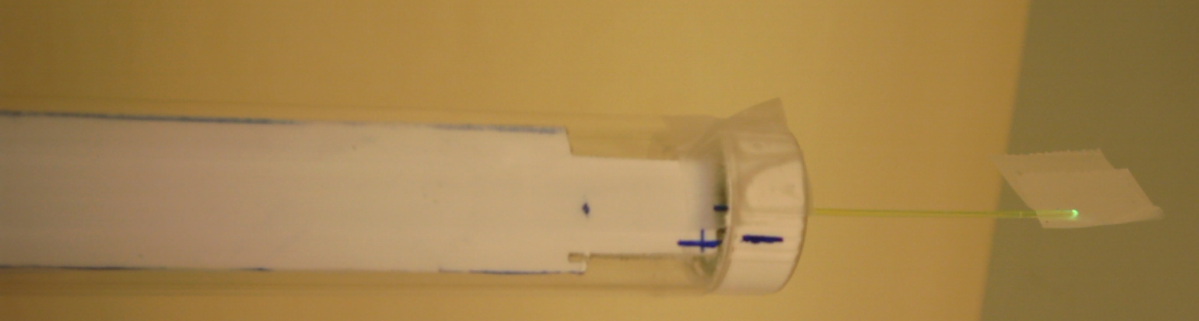
FIGURE 14: Both ends of the 50cm long Prototype 2 and 3. The left photo shows the unsealed second plug. The right photo shows the Lucite Tube, vial cap and WSF.

A third prototype, Pro 3, was created identical to Pro 2, except that the interior walls of Pro 3’s cell were painted with 3 coats of white, liquid scintillator resistant, reflective paint called EJ-520⁵ and 5-minute epoxy was used to attach the small piece of aluminized mylar to the fiber end instead of optical cement. The paint consists of a polyurethane base with titanium dioxide acting as a reflector. Two measurements were taken with each prototype, with the beam passing through the detection cell at a distance of 94mm from the snout of the PMT housing (136mm from the photocathode) and the averaged results are shown in Table 7. The painted interior walls of Pro 3 are apparently less reflective than when they are unpainted.
TABLE 7: Light yield of Prototypes 2 and 3 at a distance of 136mm from the PMT “Patrick”, at a voltage of –2150V and an attenuator setting of 1.0. The prototypes were filled with a 50/47.5/2.5 cocktail.
 | Muon Centroid Channel | Number of Photoelectrons | Electron Centroid Channel | Number of Photoelectrons
Pro 2 | 610 | 21.2 | 420 | 14.4
Pro 3 | 546 | 18.9 | 364 | 12.4

- Discussion and Conclusions
  - Regarding Beam Tests
    - Light Output
The most important observation that can be made from Figure 8 is the fact that light output is linearly dependent on the concentration of QSA in the cocktail. This, and the discovery of the effects of smudged aluminized mylar, limits the possibility of increasing the light yield to two factors: the QSA concentration and the reflectance of the surrounding material. Consequently, cocktails with as much QSA as possible, taking their water concentration into account, became the cocktails of choice. Also, it has recently become apparent that 50% water is not a high enough water concentration to significantly reduce systematic nuclear effects. Separately, the reflectance of the detection cell’s interior has become a top priority in the Prototype Tests; second only to the necessity to find a QSA resistant material from which to build the detection cells in the first place.
    - PPO/POPOP
As a third possible method of increasing the light yield, PPO/POPOP was integrated into the cocktails. In the tests on the effect of PPO/POPOP, with results presented in Figure 9, two observations become obvious. The first is that the effect of PPO/POPOP on the light yield diminishes as the QSA concentration rises. This can be explained by the fact that PPO/POPOP is both a weak scintillator and a wavelength shifter. Normally, diisopropylnaphthalene scintillates and produces light of a wavelength that does not lie within the high sensitivity range of the PMT. Other wavelength shifting chemicals in QSA normally shift that light into the usable range, but when the concentration of QSA is low, the concentration of QSA’s inherent wavelength shifter is too low to catch and shift all the light produced by the diisopropylnaphthalene. By incorporating 0.5g PPO/POPOP into the cocktail via Triton, the cocktail’s shifting efficiency is increased, but not necessarily its photon production, and a rise in light yield is witnessed. As the concentration of QSA increases, the shifting efficiency increases due to QSA’s inherent shifters and the added PPO/POPOP becomes increasingly redundant. This explains the decline in PPO/POPOP’s effect on the light yield.
The second observation is that at low concentrations of QSA (70/5/25), the addition of 0.5g PPO/POPOP increases the light yield, but the addition of 1.0g PPO/POPOP then decreases the light yield. The same pattern is repeated to a lesser extent in 70/10/20 cocktails. Perhaps this occurs because the PPO/POPOP particulates become numerous enough to actually interfere with the photons traveling through the cocktail medium. PPO/POPOP is designed to absorb photons and re-emit them, but the probability that a photon gets re-emitted is not 100%. For example, an excited PPO or POPOP molecule may de-excite by colliding with other molecules; thereby expending its energy without re-emitting the photon. With so many particulates in the medium a photon might get absorbed and re-emitted many times before striking the WSF. Frequent absorption and re-emission would lower the probability that a photon survives long enough to strike the WSF.
Of greater concern is the observation that PPO/POPOP settles out of solution over time. This makes its use in the Near Detector impossible unless embedding it in a gel prevents it from settling; in which case, a gel doped with PPO/POPOP could be an option.
    - Natural Gels
Liquid scintillators begin as very fluid liquids when their water concentration is high and the Triton concentration is low. Then, as the Triton concentration increases, the viscosity increases as well. At a certain ratio of water to Triton, the cocktail becomes a natural gel. These natural gels are not normally as clear as gels made with Carbopol, but they do carry their own intrinsic benefit; they can be turned back into a runny liquid through heating. This would, in theory, allow the cocktail to be melted and then poured into the detection cell, at which point it would cool back into a natural gel. Some preliminary observations confirm that a melted cocktail will cool into a uniform natural gel, provided that the cocktail was agitated while it was a liquid. The major drawback of these natural gels is the reduced QSA content. Natural gels only form when the QSA content is decreased from its maximum, which is detrimental to the potential light yield. A secondary point to consider is the clarity of the natural gels. In 22mL glass, scintillation vials, the added haziness or rippled effect of the natural gels did not appear to have much effect on the light yield, as is evident in Figure 8 where the light yield continues to follow a linear relation despite the natural gel’s added optical hurdles. Caution must be exercised though, because this may not hold true for a longer detection cell where a photon may have to travel a considerable distance down the cell before striking the WSF.
  - Regarding Carbopol Gels
Cocktails morphed into gels by the addition of a gelling agent produce essentially the same light output as a liquid cocktail of the same constituents. The desire to use a gel instead of a liquid is based on the idea that a gel would slow down the degradation of the WSFs if a hole in the cladding were to develop and the hope that a gel would slow down or prevent leaks in the finished Near Detector. The first idea is largely discredited by the Fiber Degradation tests. Carbopol gels have carboxylic acid groups that will increase the rate of degradation in polymers that are susceptible to acids. One test shows that the Carbopol gel version of a 72/19/9 cocktail actually caused greater damage to a WSF than a liquid 72/19/9 cocktail. If one examines Figure 6, it turns out that the rate of degradation is, in fact, greater in the Carbopol gel than in the liquid. This would suggest that a gel would not grant any special benefits if a hole in the cladding were to develop, as long as a gap in the core material has any effect on the transmitting ability of a WSF. In the 45/55/0 cocktail (vial 287), separation has occurred and the rate of fiber decay is the highest value of all the vials, which may suggest that a higher concentration then expected is surrounding the notch or fiber end. In this case, the rate of fiber decay is 0.1mm/day. This means that in the entire 10-year lifespan of the Near Detector, 36.5cm of fiber core would dissolve. Even if a gel could half that rate, an 18cm gap in the core would be just as devastating as a 36.5cm gap.
The second reason for using a gel, stopping or slowing leaks, is not convincing. The Carbopol gel leak test showed that a Carbopol gel merely slows leaks at best. Furthermore, the circumstances of the near detector operation must be considered. Since the gel merely slows down leaks, it may just complicate and magnify the problem. For instance, if a cell filled with a liquid cocktail were to develop a leak, it would leak quickly and completely empty in a few hours. Then, the photomultipliers attached to that cell would no longer produce any events and there would be a giant puddle on the floor. Both of these facts make the problem instantly recognizable and a prompt replacement of that cell’s cocktail can be undertaken. On the other hand, if that cell had been filled with gel, the gel would leak out slowly over a matter of days or weeks. This means that the light yield for that cell would decrease slowly and might not be immediately noticed either. Also, the gel itself would probably stick to whatever surface it oozed out onto and would create a mess. By the time the leak is noticed and fixed, data for an unidentifiable amount of time may have been affected by the loss in efficiency of this cell. Keep in mind that this argument is negated if the loss of a single cell is completely inconsequential to data acquisition with the detector or the operation thereof. Consequently, a Carbopol gel holds little benefit when compared to a liquid cocktail.
Another topic of note is the presence of bubbles in any gel immediately after production. If great care is taken in mixing the gel, only small bubbles that disappear over time show up in the cocktail. Larger bubbles that do not disappear arise if insufficient care is taken in the mixing process. Since the small bubbles disappear over time, it is possible to imagine that the small bubbles may be filled with a substance other than air. Perhaps they are small globules of Triton that slowly dissolve over time.
  - Regarding Material Resistance Tests
Although fiber degradation due to holes in the cladding is probably a well-based concern, a hole in the cladding large enough to allow the fiber’s core to dissolve would be a rare occurrence indeed. This observation is based on the amount of effort that had to be used to cut a notch in the outer cladding large enough to provide a hole for the WSF degradation tests and the fact that 9 WSF’s immersed in 100% Triton and incubated for 4 months showed no signs of deterioration along their shafts or their light yield.
Due to the survival of only certain materials, the options are limited as far as building materials are concerned. Polypropylene is degraded to some extent when exposed to isopropylbenzene, which is similar to diisopropylnaphthalene molecule⁶. At this point, it appears that Coroplast (polypropylene) can not resist QSA indefinitely. This leaves one last option for extrusion, which is HDPE. HDPE is considered better at resisting QSA and, hopefully, HDPE will succeed where others did not.
Due to the fact that Toluene based compounds like ProFlex and Lexel cannot survive exposure to QSA, the best adhesive to use is Titanium Silicone II or another variant of Silicone rubber like RTV Sealant. This is due to Silicone rubber’s ability to fill holes as well as adhere. Conceptually, the ends of the detection cells could be sealed with RTV and nothing else. This showed some success in the leak tests, but might make refilling the cells difficult. The second option for plugging the cells is to use Plexiglas plugs like the one in Figure 14 (left). These would effectively plug the cells, and would not be prone to leaks caused by careless installation, which might occur in the case of a worker installing their 701st RTV glob into the end of a cell. Furthermore, the design of these plugs provides a ledge to grasp and pull in the case of needing to drain or refill the cell. The fallbacks of these plugs are the cost required to produce many custom plugs, the fact that a generic plug that could fit any of the non-uniform cell walls may be difficult to produce and the fact that Plexiglas corrodes in QSA. However, the cost may be insignificant, a generic plug may be doable and another QSA resistant material may be easily used in place of Plexiglas.
  - Regarding Biological Inhibiters
Since no mould has grown in any of the deliberately infected samples, not much can be said about biological inhibiters except that it would be a good idea to use one in the finished detector, simply to avoid the possibility of mould growth. If it were assumed that all the biological inhibiters work equally well to prevent mould growth, the best candidate would be Liquipar Optima because of its minimal effect on the clarity of the liquid or gel in which it is placed. It has also been observed that aqueous solutions stored in galvanized steel containers remain free of biological growth after many years, whereas aqueous solutions stored in plastic containers do exhibit growth. It is conjectured that the metal ions of zinc and other impurities, like cadmium, in galvanized steel work to inhibit biological growth. Perhaps the addition of some zinc and/or cadmium salts to the cocktails would prevent biological growth, but that has yet to be tested.
  - Regarding Prototypes
Pro 1 provided an idea of what light yields could be expected from longer detectors. A more thorough observation could be made if a direct comparison was made between the reflectivity of aluminized mylar and the shower bar cover. As it stands, it can be expected that, in general, the light yield from a long tube is significantly smaller than that which the same cocktail would yield in a 22mL scintillation vial. Additionally, Pro 1 provided a tentative attenuation length for the WSFs; however, this value of 1.6m is shorter than expected. Previous measurements of the attenuation length of these fibers have yielded an attenuation length of about 3m. Additionally, the attenuation length measurements included signals that traveled down the WSF, away from the PMT, got reflected at the end and then traveled all the way back to the PMT. If this additional light source was taken into account, the attenuation length would be even less than 1.6m.
Pro 2 has shown that 1cm² detection cells with a single fiber can produce enough light to be useful in the case of a 50/47.5/2.5 cocktail. If the attenuation length is in fact 1.6m then 10.3 photoelectrons can be expected at a distance of 1.25m from the PMT if a Coroplast detection cell is used. This would easily satisfy the minimum light yield (2 to 3 photoelectrons) required of the near detector. If it becomes necessary, the light yield of all three prototypes would be enhanced by the addition of a second PMT at the opposite end of the cell or a second WSF extending through the detection cell.
- Where to Next?
The major difficulty now facing water scintillator research is the currently estimated minimum water content and minimum photoelectron output. Once these two values are decided upon, the final steps in development can be completed. The minimum water content will define whether a 70% or 60% water cocktail is chosen (50% has already been deemed unacceptable). Subsequently, the maximum photoelectron emittance of that cocktail can be determined and possibly increased. Some possible ways to increase the emittance include using two PMTs-one on each end of the cell, using more than one WSF in each cell, increasing the reflectivity of the cell walls with TiO₂ or other compounds, and using PPO/POPOP in the cocktail. The last suggestion is not promising, given the data based on the effects of PPO/POPOP, but should be confirmed using the cocktail of choice. One last item that should be confirmed is whether a cocktail with 0% Triton, 2.5% Triton, 5% Triton or some percentage in between produces the greatest emittance. This last item should be carried out using a cocktail container with a stable reflectivity (unlike the smudge prone aluminized mylar). The choice of Triton content should also be based on the tolerable cloud point and the long-term stability of the cocktail. Once the final cocktail has been decided upon and the details regarding Triton and PPO/POPOP content have been worked out, a long, thin, transparent tube should be filled with the cocktail and left to sit for several weeks at the temperature most likely to occur in the near detector. Hopefully, the cocktail will remain completely uniform throughout that period.
If a gel is chosen to be the medium of choice, more effort may be necessary to handle the many small bubbles that continually show up in freshly mixed gel cocktails. Two relatively simple tests should be administered to ascertain the severity of the bubbles’ presence. First, several identical gels of the cocktail of choice should be made and left at the Near Detector’s most probable temperature to see if the bubbles disappear on their own, as they sometimes do in the lab. If they do not disappear on their own, a beam test should be performed using a cocktail with as few bubbles as possible and a cocktail with a noticeably higher bubble content. It may transpire that the bubbles do not seriously hinder the cocktail’s emittance. If the bubbles do not disappear and are a problem because they waste volume, it may be necessary to look into the production of a custom-mixing chamber that is airtight and adds the proper ingredients via pump.
Because of the inability to predict whether mould will grow or not, a biological inhibiter should be incorporated into the cocktail of choice to eliminate the mere possibility of unwanted growth. Towards this end, all future cocktail tests should involve a biologically inhibited cocktail. The best candidate so far appears to be Liquipar Optima⁷.
Acknowledgements:
My sincerest gratitude goes to Dr. Stanley Yen for his patience, respect and mentoring. This semester has been an absolutely amazing experience that would not have been nearly as exciting had it not been for Dr. Yen. I would also like to extend my appreciation to Dr. Akira Konaka and Dr. Scott Oser for their support, opinions and for paying attention to my weekly yammering. My thanks also go out to Dana Giasson, Steve and Chapman for making everyday work affairs fun! I’ll also send out a special ‘Cheers!’ and Good Luck to all the other coop students with whom I shared the amazing semester and who continued to participate in my movie nights and lunch time card tourneys: Peter Watson, Wayne Cheng, Patrick Lee, Faraz Arbabi-Vahdat, Brent Lipson and Daniel Graves.

References:
- Zinsser Analytic. http://www.zinsser-analytic.com/137.asp
- Waltham, Chris. “Neutrino Oscillations for Dummies”. http://www.physics.ubc.ca/~waltham/sno_talks/dummy.htm March 2003.
- King, Jenna. “280m Near Detector Research for T2K Neutrino Oscillation Experiment”. Unpublished term paper. May 2004.
- The Chemistry Store. PPO/POPOP
- ? EJ-510 and EJ-520 paint.
- Jensen Inert Products. “Chemical Resistance Chart”. http://jenseninert.com/content/chemical.htm
- King, Jenna. “Progress and Development of T2K’s 280m Near Detector”. Unpublished term paper. September 2004.

Bibliography:
- Bahcall, John N. “Solving the Mystery of the Missing Neutrinos”. http://nobelprize.org/physics/articles/bahcall/ Last Revised: June 29, 2004.
- Jensen Inert Products. “Chemical Resistance Chart”. http://jenseninert.com/content/chemical.htm
- King, Jenna. “280m Near Detector Research for T2K Neutrino Oscillation Experiment”. Unpublished term paper. May 2004.
- King, Jenna. “Progress and Development of T2K’s 280m Near Detector”. Unpublished term paper. September 2004.
- Schneider, Adam. “Neutrino Detector R&D”. Unpublished term paper. January 2004.
- Waltham, Chris. “Neutrino Oscillations for Dummies”. http://www.physics.ubc.ca/~waltham/sno_talks/dummy.htm March 2003.
- Yen, Stan. “Personal Communication”. TRIUMF, Vancouver. 2004.

Appendix A: Recipes
Standard 20mL Liquid Cocktail
- The desired amount of deionized water is first added to a clean 22mL scintillation vial. When using disposable syringes for measuring and dispensing volumes, at least 1mL of the liquid is left in the syringe at all times to avoid injecting bubbles into the cocktail.
- The desired amount of Triton X-100 is then added to the vial by injecting it against one side of the vial to avoid the introduction of bubbles through the collision of the two liquids.
- The desired amount of Quicksafe A is added last, in the same manner as the Triton.
- The mixture is then agitated with a model boat propeller at maximum speed (rpm unknown) until the mixture looks uniform and the globules of Triton are as small as possible.
- Then replace the vial cap and let sit for an hour or so.

Standard 20mL Carbopol Gel
- Use 1.4x the amount of each liquid you expect to need to provide an extra mL for the syringe and a little buffer room. In a clean vial, mix the Quicksafe A, Triton and NaOH_{aq} with a stir rod until the mixture appears uniform.
- In a 50mL beaker, mix the Carbopol stock mixture with the water. Keep in mind that the Carbopol already contains some of the required water.
- Using disposable syringes, add a pre-calculated amount of the first mixture to a new clean vial. Then add a pre-calculated amount of the second mixture, keeping track of how much of each mixture you have added. Continue to add a little of each mixture at a time to the new vial until a volume of 20mL has been attained.
- Calculate the amount of each mixture to add each time based on the desired ratio of one mixture to the other. For instance, if you need 8mL of the QSA, Triton, NaOH mixture then add 0.8mL of that mixture each time until you’ve added it 10 times.
- While the aliquots are being added, stir the gel with the model boat propeller, by hand, periodically, and leave the propeller in the vial between aliquot additions. Be very careful when stirring near the surface of the gel to avoid sucking giant air bubbles into the gel.
- When the 20mL have been added, stir until the gel appears uniform. Then cap the vial and leave overnight.

50mL of ~2wt% (~0.5M) NaOH
- Since the molar mass of NaOH is 40g/mol, it follows that 1g of NaOH_{(s)} should be added to 50mL of water to produce a 0.5mol/L solution (or 2wt% NaOH solution).
- However, since NaOH_{(s)} is hygroscopic, the mass of NaOH_{(s)} to be added should be increased by 10% to approximately account for the mass of the water that the NaOH_{(s)} has picked up. Thus, 1.1g NaOH_{(s)} should be added to 50mL deionized water.
- The NaOH_{(s)} tablets can be measured out on a piece of paper on a top loading balance and added directly to the water. Replace the lid and invert 20 times to insure uniform mixing.

0.1g Carbopol per 5mL Water Stock Solution
- To make 100mL of Carbopol stock solution measure out 2.0g of Carbopol and add it to 100mL water.
- The powder will pile up on top of the water. Do not stir. All of the Carbopol will be absorbed by the water if it is left to sit overnight. The resulting solution should be uniform.

